MATHEMATICS SPECIALIST

MAWA Year 12 Examination 2017

Calculator-assumed

Marking Key

© MAWA, 2017
Licence Agreement
This examination is Copyright but may be freely used within the school that purchases this licence.
- The items that are contained in this examination are to be used solely in the school for which they are purchased.
- They are not to be shared in any manner with a school which has not purchased their own licence.
- The items and the solutions/marking keys are to be kept confidentially and not copied or made available to anyone who is not a teacher at the school. Teachers may give feedback to students in the form of showing them how the work is marked but students are not to retain a copy of the paper or marking guide until the agreed release date stipulated in the purchasing agreement/licence.

The release date for this exam and marking scheme is
- the end of week 1 of term 4, 2017

Question 8 (a)

Solution
Also
In addition, and
Specific behaviours
calculates the modulus and argument of correctly
relates the modulus and argument of to those of

Question 8 (b)

Solution
Now
As this means that
Specific behaviours
uses De Moivre’s theorem to express answer as an exponential
simplifies answer to form of an exponential of small argument
obtains correct answer in Cartesian form

Question 9 (a)

Solution
Let gm denote the average weight of a randomly chosen coffee bean
Then 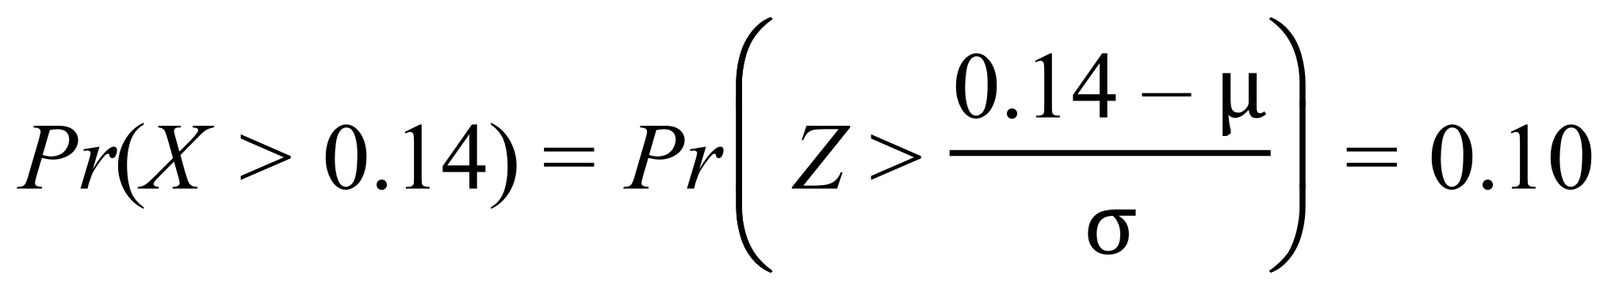 and so
and so that
Solving equations (A) and (B) gives 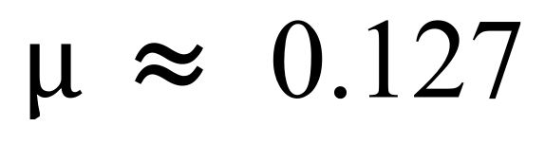 and 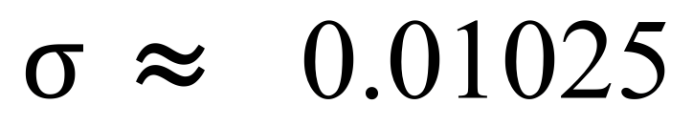
Specific behaviours
obtains equation (A)
obtains equation (B)
solves for and correctly

Question 9 (b)

Solution
If the 10 beans in the random sample weigh more than 1.2 gm, then
where is the average weight of beans in the sample.
Now
i.e.
Specific behaviours
uses mean and correct standard deviation for
obtains correct answer

Question 9 (c)

Solution
Now
But and

Hence the required probability is 0.67.
Specific behaviours
obtains correct bounds for the probability in terms of 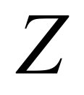
evaluates limits correctly
derives correct answer

Question 10 (a)

Solution
If

Then we have

Hence we deduce that
Specific behaviours
Combines the two given fractions correctly
Expands the parts of the numerator
Writes the three correct equations for the constants
Solves for the constants

Question 10 (b)

Solution
Specific behaviours
integrates the two partial fractions correctly
simplifies the solution to the required form

Question 11(a)
Solution
Substituting into the two vector equations and

Specific behaviours
correct answer for

Question 11(b)
Solution
Differentiating with respect to gives
Specific behaviours
differentiates each position vector correctly

Question 11(c)
Solution
Since the velocity vector of each plane is independent of , the velocity of each plane is constant, indicating motion in a straight line.

The speed of plane A is
while the speed of plane B is 3 km/min.

The flight path of plane A is trending upwards while the flight path of plane B is trending downwards.
Specific behaviours
remarks that the velocity of each plane is constant/linear flight path
calculates the speeds of the two planes
states the vertical direction of each plane.

Question 11(d)
Solution
Using a CAS calculator, determine an expression for the distance
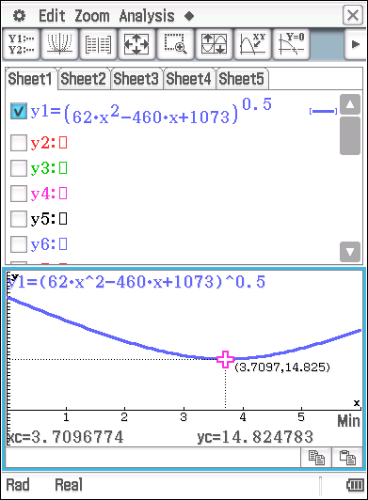
Graph the expression using the graphing app
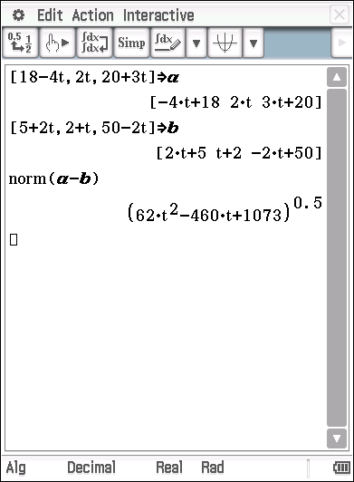

Use the ‘Analysis’ function on the CAS
To determine the minimum distance between the two planes.

Min distance = 14.825 km
Occurs when t=3.71 approx
Specific behaviours
draws a graph with the appropriate shape
calculates the correct min distance and gives the corresponding time

Question 12 (a)

Solution
The function 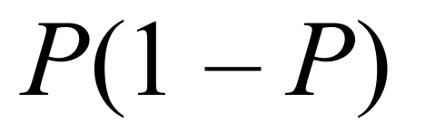is a quadratic with a maximum at 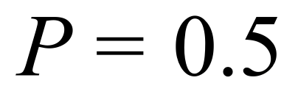
This corresponds to half the population.
Specific behaviours
recognizes the quadratic nature of the derivative function

Question 12 (b)
Solution
Separating the variables in the differential equation gives
and so
Therefore for some constant c.
Specific behaviours
separates the variables correctly
integrates each side correctly

Question 12 (c)
Solution
Substituting into the expression in (b) gives and so
Hence
Specific behaviours
obtains correct value for 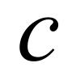
derives the correct equation

Question 12 (d)
Solution
Since then and
Then
Specific behaviours
takes exponentials correctly
derives correct formula for 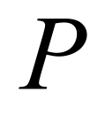

Question 12 (e)
Solution
When then
So it takes about 75.4 days for 95% of the population to be infected.
Specific behaviours
derives an equation for the required time
obtains correct answer

Question 13 (a)(i) (11 marks)

Solution
If

Thus

Specific behaviours
Rearranges to obtain in terms of
Interchanges and in formula
Deduces the form of the inverse function

Question 13 (a)(ii)

Solution
Domain is ; Range is
Specific behaviours
States domain and range correctly

Question 13 (b)

Solution
Now

The composite is only defined where is defined so that .

Specific behaviours
Determines the correct composite function
Identifies the correct domain of definition.

Question 13 (c)

Solution
Recall that if and that for

Then

Case 1:

Case 2:

Case 3:
.
But this is a contradiction as it has been assumed that

Hence the solutions of the equation are

Specific behaviours
Draws correct conclusion from case 1
Solves equation in case 2
Solves equation in case 3
Recognises that the apparent solution in case 3 contradicts the assumed range
Synthesises results from the three cases to deduce the correct solution of the problem

Question 14(a)
Solution
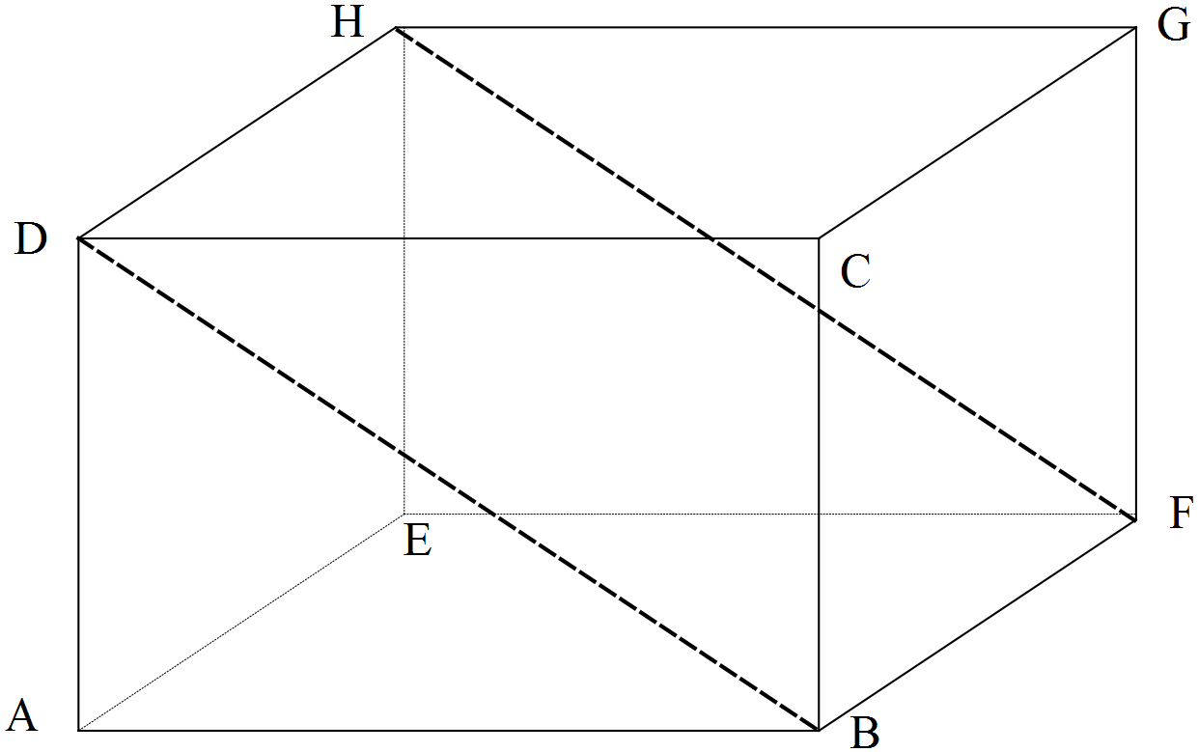
Specific behaviours
uses the dot product and expands correctly
uses and states why it is zero
deduces the correct result

Question 14(b)
Solution

Specific behaviours
determines in terms of using part (a)
determines and in terms of
sums to find the result =
show this equals

Question 14(c)
Solution
The sum of the squares of the diagonals of a rectangle are equal to twice the sum of the squares of any two adjacent sides of the rectangle.
Specific behaviours
states a correct interpretation of the result

Question 15 (a)

Solution
We want i.e.
Therefore and so we need to test at least 48 tyres.
Specific behaviours
obtains correct inequality
solves for 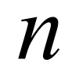 correctly

Question 15 (b)

Solution
The confidence interval is where
Hence the confidence interval is
i.e.
Specific behaviours
uses correct form for the confidence interval
obtains correct value for 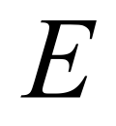 the margin of error
obtains correct limits for the confidence interval

Question 15 (c)

Solution
The sample does provide some evidence to dispute the manfacturer’s claim because the sample mean is less than 40000.

However, the confidence interval contains some numbers greater than 40000, and so the evidence for rejecting the claim is not compelling.

Specific behaviours
notes that there is some evidence for disputing the claim
recognises that the evidence for rejecting is not overwhelming.

Question 16 (a)

Solution
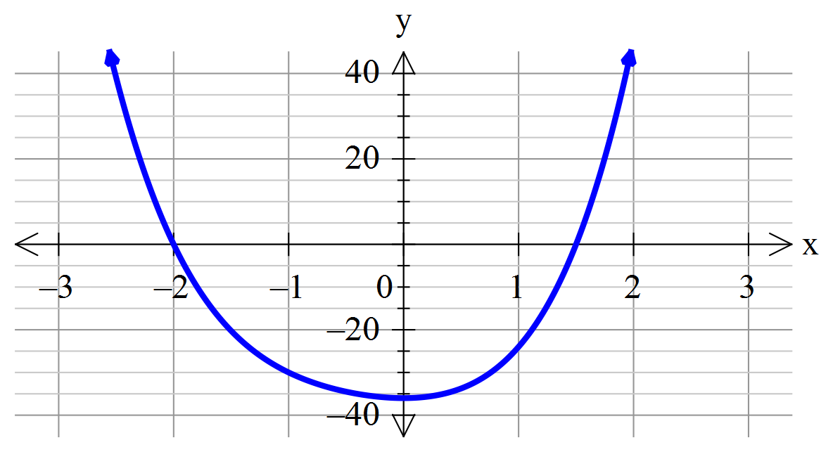
The graph suggests zeroes at and .
To check this we calculate
and

Specific behaviours
estimates zeroes at and from a graph
checks these are correct by direct substitution

Question 16 (b)

Solution
Since roots of are and this suggests that
is a factor of .

By long division we observe that

If
Hence the solutions of are and .
Specific behaviours
identifies the two linear factors that follow from (a)
conducts the long division correctly
writes down the solution of the quadratic and hence finds correct complex zeros

Question 17 (a)

Solution
If then
and

Hence
as required

Specific behaviours
obtains correct expression for
obtains correct expression for
completes proof

Question 17 (b)

Solution
Since
so

Specific behaviours
obtains correct expression for the velocity
deduces the correct value for the constant

Question 17 (c)
Solution
The spring is stationary when i.e. when
i.e. when
The least positive solution of this equation is

So the spring is first stationary at time seconds approximately
Specific behaviours
obtains equation for stationary times
calculates the correct answer

Question 17 (d)

Solution
From part (c) the spring is stationary when
The solutions are then where  is any non-negative integer.
These form an arithmetic sequence with common difference is .
Specific behaviours
obtains general solution for the stationary times
states the correct common difference between these times

Question 17 (e)

Solution
At a local maximum of we have
This occurs when where
Now
We know that will be positive if is even and negative if is odd

Hence the local maxima of 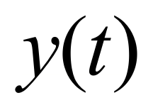 correspond to even.
So the local maxima of  are given by where 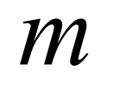 is any non-negative integer.

These form a geometric sequence in which the common ratio is
Specific behaviours
evaluates  at the stationary point
shows that every second stationary point is a local maximum
realises the maxima correspond to even values of
observes the maxima values constitute a GP and states the common ratio

Question 18 (a)

Solution
For the region the parabola is above the x-axis so the required area is

Specific behaviours
states correct limits of integration
writes a correct expression for the area
integrates all the terms correctly
substitutes in values to determine the area

Question 18 (b)

Solution
If rotating about -axis have that
To compute volume around y-axis need to evaluate
The second volume is determined by calculating the volume generated by rotating the right-hand branch of the parabola about the axis and subtracting the volume formed using the left-hand branch of the parabola.
The parabola is . Hence
Right hand branch is with +sign and is defined by . Then
Left hand branch is with – sign and is also defined by . Then
Thus volume generated by rotating about the axis is
Hence we see that
Specific behaviours
writes down correct form of integral for first volume
integrates correctly and hence evaluates to determine the volume (candidates are expected to use calculator for the manipulation)
realises that for rotation is about y-axis the required integral is of form
gives clear statement of strategy adopted to determine the volume
determines the appropriate formulae for the two branches of the parabola
for volume forms correct integral with limits. Evaluates correctly (calc allowed)
for volume forms correct integral with limits. Evaluates correctly
deduces the correct relationship between and

